|  |  |  |  |  |  |  |  |  |  |  |  |  |
| --- | --- | --- | --- | --- | --- | --- | --- | --- | --- | --- | --- | --- |
| **Software Design Specifications**  Drone Navigation Using Brain-Computer Interface (BCI)  Version: 1.0   |  |  | | --- | --- | | Project Code | 19S-16 | | Supervisor | Dr. Ahsanullah Abro | | Co-Supervisor | Dr. Ahmed Ali Shah | | Project Manager | Muhammad Raheal Safdar | | Project Team | Naneeta  Madiha | | Submission Date | 20th September 2022 | |

**Table of Contents**

**1. Introduction 3**

**1.1. Purpose of Document 3**

**1.2. Scope of the development project 3**

**1.3. Definitions, acronyms, and abbreviations 3**

**2. Design Considerations 4**

**2.1. Assumptions 4**

**2.2. Constraints 4**

**2.2.1. Platform 4**

**2.2.2. Operating System 4**

**3. Architecture 4**

**3.1. Overview: 4**

**4. Detailed Software Design 5**

**4.1. Use Case Diagram: 5**

**4.2.** **Sequence Diagram: 6**

1. Introduction
   1. Purpose of Document

This document aims to build a BCI system that control drone navigation. In this document, we will create use case diagram, sequence diagram and system architecture, which help us to create our system easily.

* 1. Scope of the development project

Drone navigation using BCI is not a new idea but it can be game changer. There are plenty of solutions in market that are used to control the drone but they all involve the physical interaction of user with controller e.g., a mobile app and remote. In a mobile app user will have to use his hand to control drone and it is the case with remote controller. There is another technological advancement, which we have proposed where less physical interaction is needed and that is BCI which uses brain signals to control the drone with the help of OpenBCI headset.

After designing and development of the project, we will be able to provide a system that will help user to control drone by wearing EEG headset. A user will have to wear EEG headset and will think of any of the six commands that are left, right, takeoff (up), land (down), forward and backward to move the drone in respective direction. One of the limitations of this project is that drone will be controlled only in six directions and no more movements like rotation, bending and flipping will not be entertained and secondly, as EEG signal is sensitive input so there will be latency tradeoff because we cannot match the same speed of remote control or mobile app with brain signals. Furthermore, this project can be extended by adding functionalities like weight lifting and photography using drone.

* 1. Definitions, acronyms, and abbreviations

1. BCI – Brain Computer Interfaces
2. EEG – Electroencephalography
3. SRS – Software Requirement Specification
4. SDLC – Software design life cycle
5. OS – Operating System
6. Design Considerations
   1. Assumptions

A1: OpenBCI headset is connected with the OpenBCI GUI.

A2: Wi-Fi and Bluetooth are available.

A3: Tello Edu drone is switched on.

* 1. Constraints
     1. Platform

C1: Works well on PC.

* + 1. Operating System

C2: It can work windows operating system 8 or higher.

1. Architecture
   1. Overview:

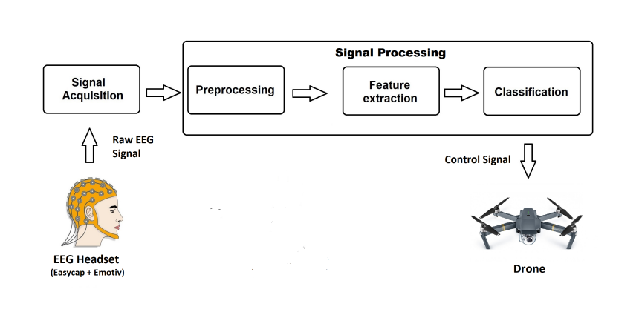

1. Detailed Software Design
   1. Use Case Diagram:

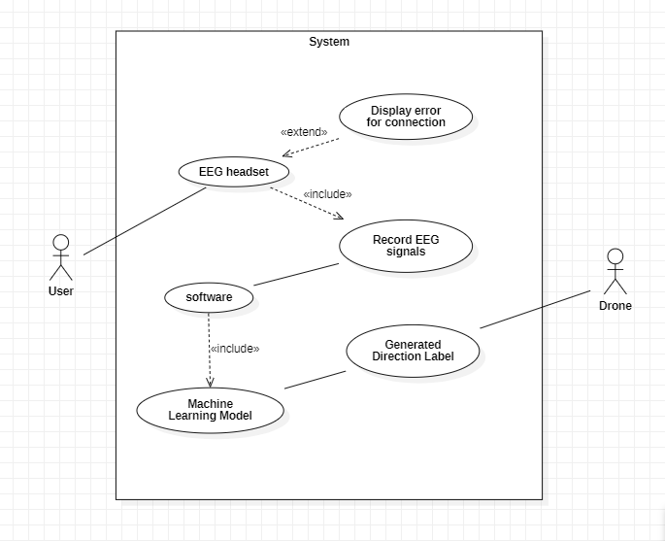

* 1. 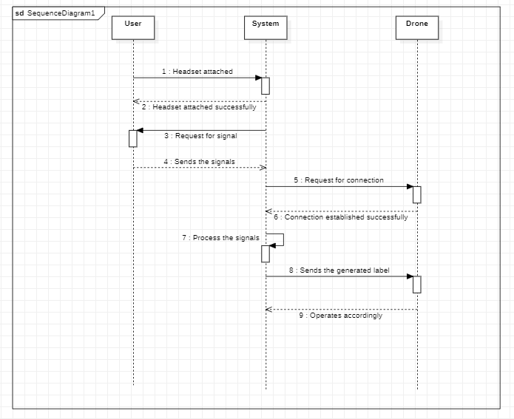Sequence Diagram: